**2020 Census Business Architecture Domain View**

The [2020 Census Enterprise Architecture and Infrastructure Transition Plan] (CEAITP) helps to realize the desired Solution Architecture that can fulfill the business goals of achieving cost efficient Census via modern technology, and implementing innovative Census operations as laid out in the 2020 Census Operation Plan for:

•Reengineering Address Canvassing;

•Optimizing Self-Response;

•Utilizing Administrative Records and Third-Party Data; and

•Reengineering Field Operations.

The 2020 CEAITP is designed to support the 2020 Operational Plan. With a phased approach aligned with the Census Tests, the 2020 CEAITP aims to ensure that the 2020 Census Program is not at risk of having to integrate solutions too late in the planning cycle. The sequencing timeline in the 2020 CEAITP shows that by the start of the 2018 End-to-End test, the majority of the business capabilities and systems must be in place. In addition, the Solution Architecture with its systems and services must be designed to meet the requirements for scalability, reliability, and availability.

**2020 CEAITP Purpose Strategies:**

The 2020 CEAITP is developed according to three strategies:

•First, the transition process is incremental by nature, as the Solution evolves from the current to target state. The Census Tests will demonstrate the progress of the implementation of the Business operations, and the capabilities provided by the Applications, and the IT Infrastructure.

•Second, the sequencing of the 2020 CEAITP has timelines for the architecture domains Business, Application, Information, Technical, Security, and Quality-, and consists of evolving these domains from the current state to the target state. The technical quality attributes of scalability, availability, reliability, resilience, and security are factored in the evolution of the 2020 Solution and propagated down to the levels of IT systems, services, and infrastructure components.

•Third, the transition maximizes the utilization of Enterprise standards, patterns and Programs, including CEDCaP and CEDSCI, and aims at consolidating similar capabilities into a common service or system. The modernization of the 2020 Solution will be enabled by emerging technologies that are SOA, Cloud, Mobile, and Web, while adhering to Federal directives for Cloud First, API, and Shared Services.

Finally, the 2020 Census Enterprise Architecture and Infrastructure Transition Plan is a living document, that will drive the collaborative process and be refined or adjusted to minimize risk and maximize efficiency, yet meet the ultimate timelines of 2018 End-to-End Test and 2020 Census Day.

**Four Key Innovation Areas:**

As mentioned above, four key innovation areas that are the focus of the 2020 Census design:

•Reengineering Address Canvassing

•Optimizing Self-Response

•Utilizing Administrative Records and Third-Party Data

•Reengineering Field Operations

**Reengineering Address Canvassing** is designed to reduce the amount of in-field labor required to update the Master Address File (MAF) and associated technical products used for assessing where to count. In-office Address Canvassing (AdCan) will be completed nationwide using imagery and address files shared by local and tribal governments. In-office AdCan is less expensive than in-field AdCan, but infield AdCan will still be required in up to 25% of all addresses. The plans for reengineered address canvassing are expected to reduce field workload by up to 75% by adding new addresses to the Census Bureau's address frame using Geographic Information Systems (GIS) and aerial imagery instead of sending Census employees to walk and physically check all the census blocks.

**Optimizing Self-Response** is designed to maximize the degree to which the respondent pool can successfully self-respond, reducing the cost of paper data capture and in-person Nonresponse Follow-up (NRFU). By encouraging the population to respond to the 2020 Census using the Internet or the telephone, the need for more expensive options are reduced.

**Utilizing Administrative Records and Third-Party data** is designed to reduce field workload by improving the efficiency of NRFU operations. By using these alternative sources of data, NRFU operations can eliminate the need for multiple unproductive visits to housing units that are vacant, abandoned, or otherwise unoccupied. It is expected that some nonresponding housing units will be enumerated in the 2020 census by using administrative records. The 2020 Census will enumerate many Group Quarters (GQs) through reference to administrative-type, third-party data. By using data the public has already provided to the government and data available from commercial sources, the Census Bureau can realize savings to focus additional visits in areas that have been traditionally hard to enumerate.

**Reengineering Field Operations** is designed to increase the efficiency of field operations, allowing managers and field workers to be more productive and effective. Combining new operational control software and case management tools with GPS-enabled devices will improve the efficiency of field workers and allow faster and more accurate management of field worker labor and travel expenses.

Using sophisticated operational control systems, Census employees can follow up with nonresponding housing units and keep better track of the daily progress of field workers.

**Program overview**

Figure 2-1 provides a high-level overview of how the 2020 Census will be conducted. This design reflects a flexible approach that takes advantage of new technologies and data sources while minimizing risk.

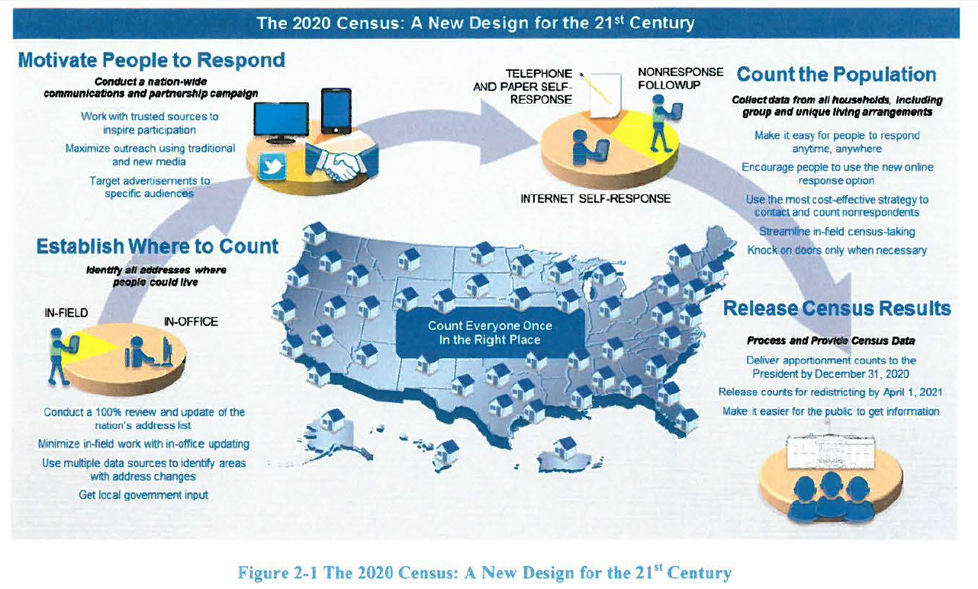

Successful execution of the 2020 Census will require coordinated efforts across a number of Census Bureau programs and will make use of resources from across the Census Bureau. The capabilities required to compete the 2020 Census are expected to be developed in an evolutionary fashion, with periodic large scale tests designed to exercise these emerging capabilities in realistic settings. Each builds successively from the prior tests, so that by the time of the first 2020 Census operations, the requisite capabilities are in place and have been field tested under realistic conditions.

**Operational Design Overview**

The iterative development process described above, which is unlike past decennials, incorporates lessons learned from early research, testing, and analysis. The lessons learned drive updated requirements for capabilities and acquisitions. Another important difference for 2020 is the emphasis on enterprise standards and solutions, such as the CEDCaP and CEDSCI initiatives, both of which are expected to provide substantial support for the 2020 Census.

Another significant difference from earlier Census designs is the focus on innovations to improve efficiencies and reduce costs. The innovations in Reengineering Address Canvassing, Optimizing SelfResponse, Utilizing Administrative Records and Third-Party Data, and Reengineering Field Operations could potentially reduce the cost of the 2020 Census by over $5.2B as compared with repeating 2010 Census methods in 2020.

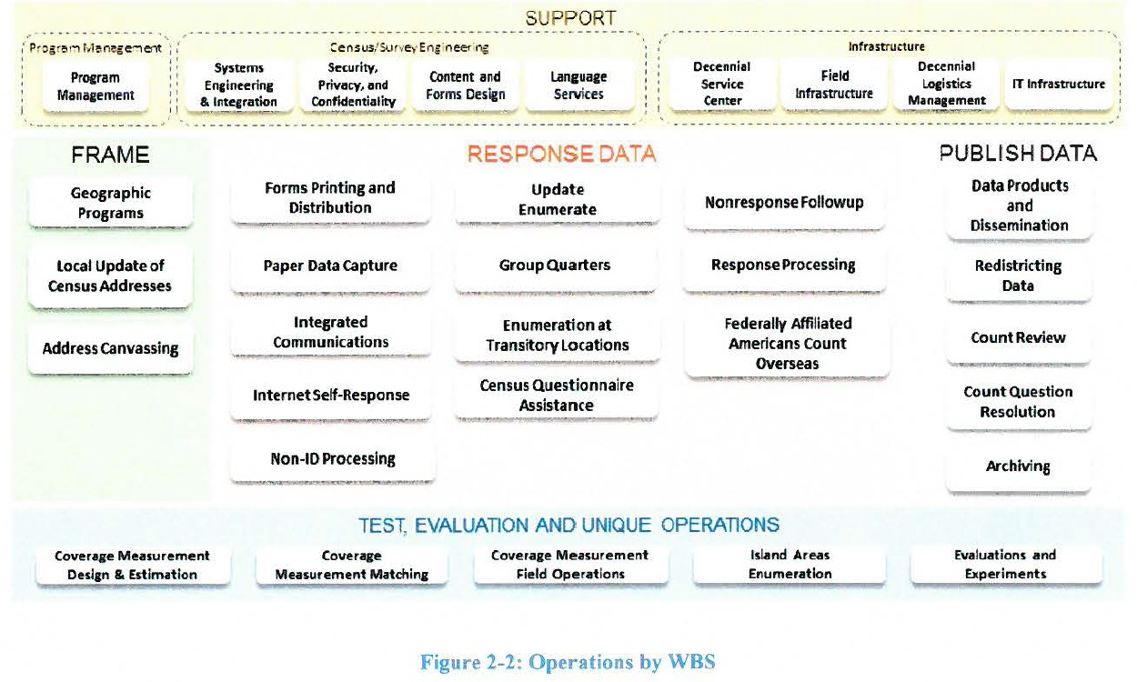

In addition to the four major innovations mentioned in Section 1, the 2020 Census will include a number of key innovations that impact many of the large, complicated operations. Innovations are considered significant changes to the operational design as compared to the 2010 Census. Figure 2-3 highlights in brown the operations have the most significant innovations. The specific innovations for each of these operations are listed in Table 1 below.

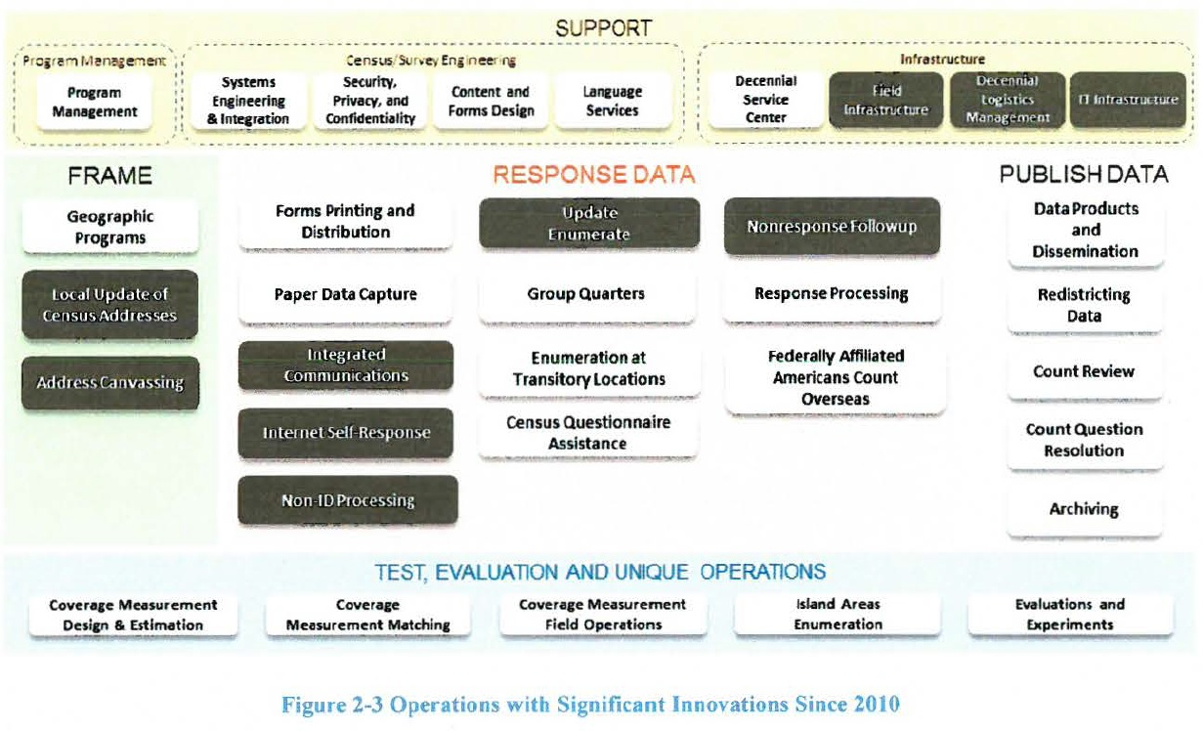

**Table I Summary of Key Innovations by Operation**

|  |
| --- |
| **Local Update of Census Addresses**  • Reduced complexity  • Elimination of the full address list submission options to improve quality and reduce burden and cost |
| **Address Canvassing**  • Use of a combination of In-Office and In-Field methods to achieve a 100 percent address canvassing (target of 25 percent of addresses going to In-Field)  • Use of automation and data (imagery, administrative records, and third-party data) for InOffice Address Canvassing  • Ongoing MAF Coverage Study to validate In-Office procedures, measure coverage, and improve In-Field data collection methodologies  • Use of reengineered field management structure and approach to managing fieldwork, including new field office structure and new staff positions |
| **Integrated Partnership and Communications**  • Micro-targeted messages and placement for digital advertising, especially for hard-to-count populations  • Advertising and partnership campaign adjusted based on respondent actions  • Letters, postcards, and questionnaires to motivate self-response  • Expanded predictive modeling to determine the propensity to respond by geographic areas  • Expanded use of social media |
| **Internet Self-Response**  • Internet data capture, providing real-time edits, ability to capture household entries, and multi-access methods across different technologies (e.g., computers, phones, tablets, kiosks)  • Online questionnaires available in multiple languages and non-Roman alphabets  • Multi-mode contact approach tailored to demographic or geographic area  • A phone option (via Census Questionnaire Assistance) will be available for respondents, who need help or without Internet access, to provide their census data.  • Paper questionnaires will be provided in the first mailing to some areas of the country, and will also be sent to all nonrespondents after a few weeks. |
| **Non-ID Processing**  • Ability for public to respond anytime, anywhere  • Real-time matching and geocoding of responses  • Validation of response data  • Use of administrative records and third-party data used to validate identity and validate and augment address data submissions |
| **Update Enumerate (planned innovations dependent on funding of this operation)**  • The 2010 Census Update Leave and Update Enumerate Operations combined into a single operation  • Single visit with enumeration or push to Internet Self-Response  • Use of single device for both listing and enumeration  • Use of reengineered field management structure and approach to managing fieldwork, including new field office structure and new staff positions  • Assignment and route optimization  • Automated training for field staff  • Automation of the field data collection  • Automation of administrative functions such as recruiting, onboarding, and payroll  • Reengineered quality assurance approach |
| **Nonresponse Followup**  • Use of administrative records and third-party data to remove vacant housing units from the NRFU workload  • Use of administrative records and third-party data to enumerate some nonresponding occupied housing units from the NRFU workload  • Use of reengineered field management structure and approach to managing fieldwork  • Use of a variable contact strategy and stopping rules to control the number of attempts made for each address (based on paradata)  • Assignment and route optimization  • Automated training for field staff  • Automation of the field data collection  • Automation of administrative functions such as recruiting, on boarding, and payroll  • Reengineered quality assurance approach  • The notice of visit will provide the Internet URL to still encourage self-responses |
| **Field Infrastructure**  • Reduced number of Regional Census Centers managing a reduced number of local field offices tasked with managing field operations and support activities  • Automated job application and recruiting processes, payroll submission and approval process, and other administrative processes resulting in reduced staffing requirements  • Automated training  • Reduced number of enumerators and supervisors due to reengineered design for field operations |
| **Decennial Logistics Management**  • Implementation of an on-line, real-time Enterprise Resource Planning (ERP) system with extended access for the Regional Census Centers and field offices  • Implementation of a wireless network and bar code technology that will automate inventory transactions |
| **IT Infrastructure**  • Early development of solutions architecture  • Use of enterprise solutions as appropriate  • Iterative deployment of infrastructure aligned with and based on testing  • Implementation of alternatives to providing Government Furnished Equipment such as Device as a Service  • Use of demand models to help predict Internet response volume, Census questionnaire assistance center staffing, etc.  • Scalable design  • Agile development of applications |